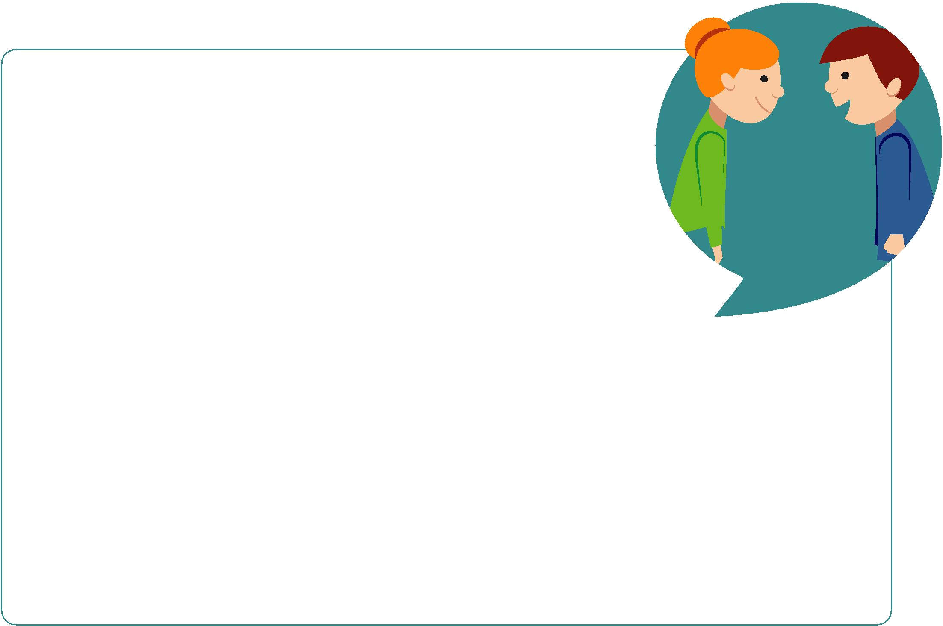

What
matters
to you?

@WMTYScot  whatmatters2you www.whatmatterstoyou.scot

