‘What matters to you?’ day
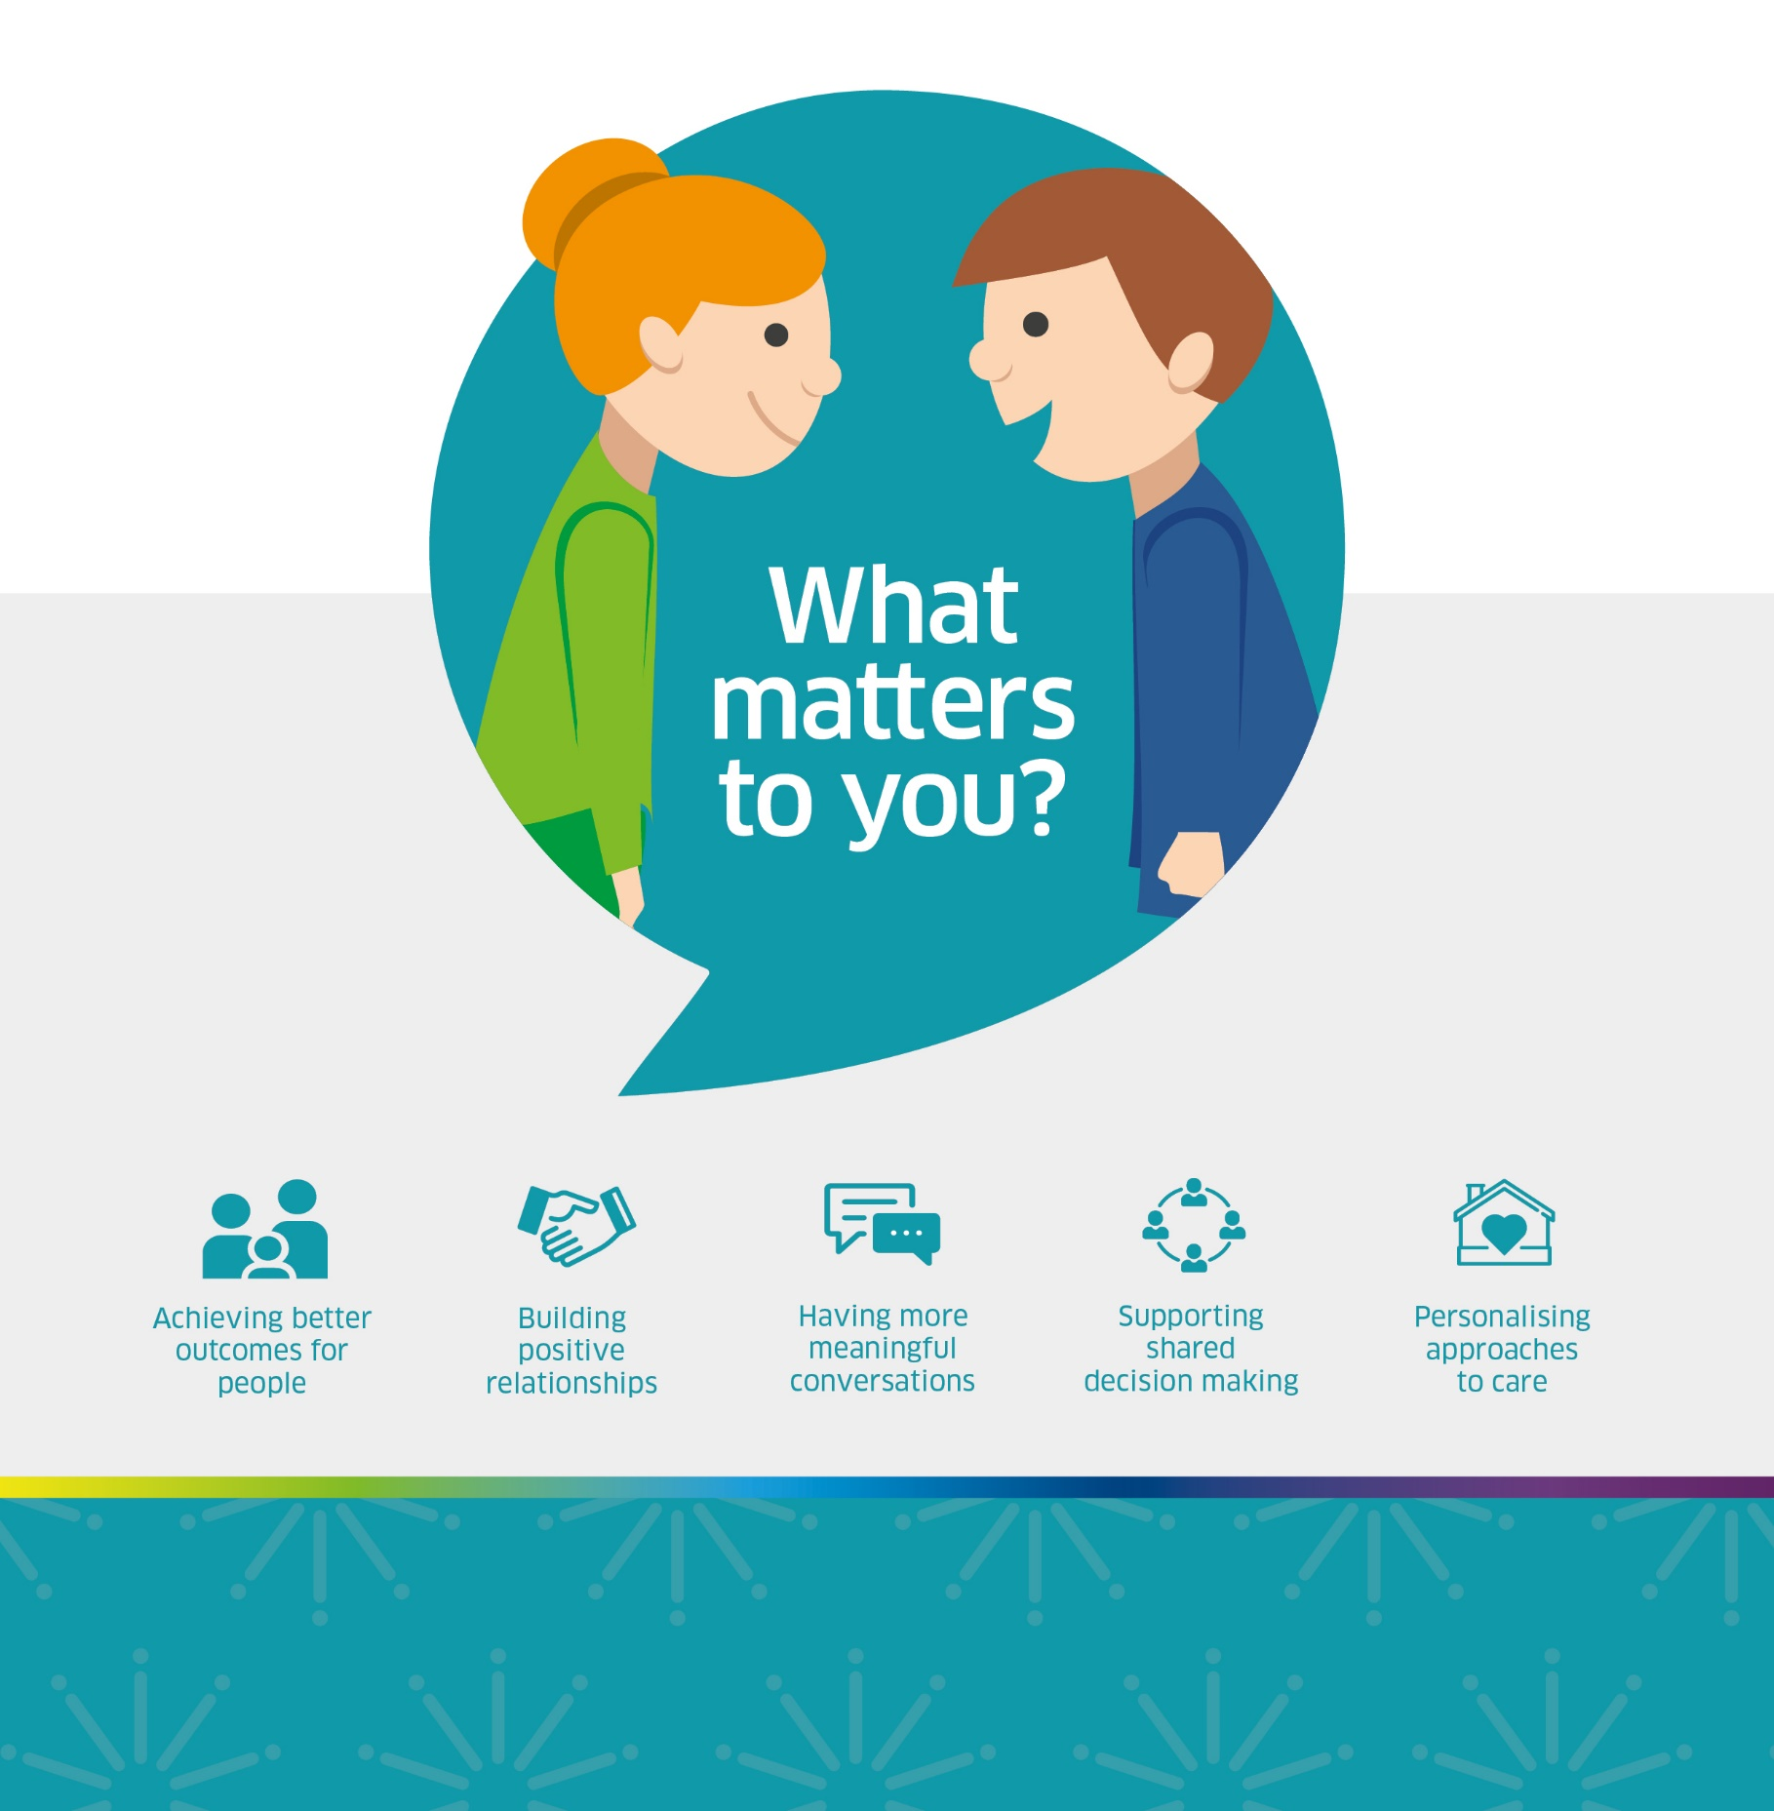
Annual Report 2022

© Healthcare Improvement Scotland 2022
Published December 2022
This document is licensed under the Creative Commons Attribution-Noncommercial-NoDerivatives 4.0 International Licence. This allows for the copy and redistribution of this document as long as Healthcare Improvement Scotland is fully acknowledged and given credit. The material must not be remixed, transformed or built upon in any way. To view a copy of this licence, visit https://creativecommons.org/licenses/by-nc-nd/4.0/

1 Contents
1 Contents 3
2 Foreword 4
3 Introduction and context for 2022 6
4 Statistics 8
5 Case Study 11
6 Key learning and next steps 14
7 Appendix 1 – Working Group 2022 16

2 Foreword
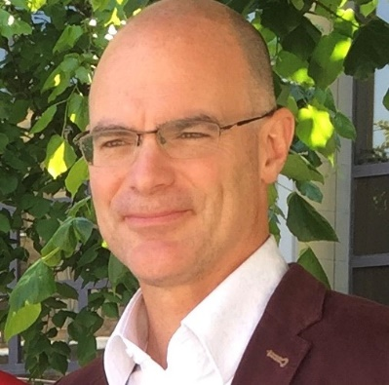
This is the seventh year that we have participated in the annual “What matters to you?” (WMTY) event on or around June 6th. Much has happened since our Norwegian friends first came up with the idea of having a special day to promote and celebrate the importance and value of the WMTY conversation. The movement has grown both at home and abroad with teams from more than 50 countries joining our movement. In Scotland, the awareness of, and focus on the WMTY approach has become widespread in many health and care settings. Thank you to all of you for all you have done and the work you are doing every day to make sure we provide care and support that is compassionate and effective.

With these things in mind, it feels like now is the right time to think about how we continue to grow and develop our Scottish WMTY network. We are keen to explore new opportunities to bring people together around this important aspect of our work and build on the awareness and enthusiasm that has developed over the past seven years. We are also interested in developing ways to demonstrate the impact of this work and the real value in generates in people’s lives, as well as the benefits for staff and organisations. There are many hundreds of people working in health and care services in Scotland who rightly recognise that the WMTY ethos is not just about one day a year but should be the way we work with every person, every day. Many teams have developed ways to achieve this, whilst others struggle in the busyness of our modern health and care system, especially in light of the challenges we have faced in recent years. As we move forward we would like to create more opportunities for you to share and learn together, to support one another and find new ways to work.

The last two years in particular have reminded us of the importance of compassionate human connection and interaction - this is the essence of the WMTY ethos. Making the space to connect, to listen and understand helps us to stay in touch with the deeper meaning and purpose of our work, reminding us of the great privilege we have in the caring professions. It helps to ensure that we always see the person in front of us, keeping us in touch with our core values as we prioritise our work and support people to get the outcomes that matter to them. Prioritising the time for a WMTY conversation is also good for us individually, whether that be a WMTY conversation with a person we are supporting or with a colleague. There is a burgeoning body of evidence demonstrating the positive impact of compassionate interactions on personal wellbeing and resilience. So, please take the time to give yourself a boost through participation in a WMTY conversation – it’s a win-win!

I would like to thank the team at Healthcare Improvement Scotland for their hard work over the past seven years, supporting and coordinating this work, and preparing these reports. We look forward to continuing that relationship and building on this important work in the years that lie ahead.

Shaun Maher, Strategic Advisor for Person-Centred Care, Healthcare Quality and Improvement Directorate, Scottish Government

3 Introduction and context for 2022
3.1 The ‘What matters to you?’ (WMTY) working group has led co-ordination and promotion of this initiative in Scotland since 2016. This group includes members of the public, representatives from Healthcare Improvement Scotland, Scottish Government, NHS boards, and representation from third sector organisations including the Health and Social Care Alliance Scotland (the ALLIANCE), CEMVO Scotland and See Me Scotland (see Appendix 1).
3.2 WMTY day, around 6 June each year, aims to showcase, encourage and celebrate more meaningful conversations so that they are embedded and take place routinely between people who provide health and social care and the people who receive care and support, as well as their families and carers. Furthermore, over the last few years while still promoting WMTY day as a day of celebration, the focus for the working group has moved more to the message that it is something we do every day and we have noted the drive to accomplish this in health and social care services across Scotland.
3.3 Registration to be involved in the day opened on 25th April 2022 and 651 people or teams registered by 8th June. As in previous years, resources were distributed across Scotland. Resources included badges, pens, posters, post-its, coasters, notebooks, handy guides and stickers, with some of the resources available online for download. These were used and adapted by people participating both in Scotland and across a range of other countries, as illustrated in section 4.
3.4 The ‘What matters to you?’ movement is not about the campaign resources or counting the countries participating, although that does help to show the growth and reach of the movement. WMTY is about conversations, human connections and understanding of what people really want and need to live the best life they can (Ballatt & Campling, 2011). In health and social care when people are routinely asked ‘What matters to you?’ it leads to more positive experiences, results in higher quality and better outcomes. Working in an environment with a ‘What matters to you?’ culture can have a positive impact on staff experience, as highlighted in the NHS Tayside case study, as seen in Section 5.
3.5 Throughout 2022, it was observed that asking “what matters to you?” moved beyond the traditional health and social care setting. It has been asked in settings such as:
- University entrance essays and becoming increasingly asked at job interviews.
- The Scottish Parliament asked “What matters to you?” of its population to establish what issues it should focus on between 2021 and 2026.
- Cornwall Council ask “What Matters to You?” of its electorate on an annual basis.
- West Mercia Police asked the question to help in their budget setting, other police forces asked it to help prioritise geographical areas to concentrate their limited resources on.
3.6 Against the background of the worldwide coronavirus pandemic, the ethos of ‘WMTY’ has never been more important or more recognised in what has been yet another challenging year for everyone, but in particular for those working in and those receiving health and social care.

4 Statistics
Social media remains the principal way that WMTY is communicated and publicised within Scotland, and with our colleagues across the world.

4.1 Twitter
Through Twitter we continue to track significant international activity across the world, with people sharing photos, activities, successes and feedback using @WMTYScot and #WMTY22.
During the whole of June 2022 #WMTY22 Twitter activity was noted in 38 countries. These were:
Argentina | Finland | New Guinea | South Africa
Australia | France | New Zealand | Spain
Bangladesh | French Guyana | Nigeria | Sweden
Belgium | Hong Kong | N. Ireland | Turkey
Brazil | Indonesia | Norway | United Arab Emirates
Canada | Ireland | Poland | United States
Denmark | Kenya | Romania | Wales
England | 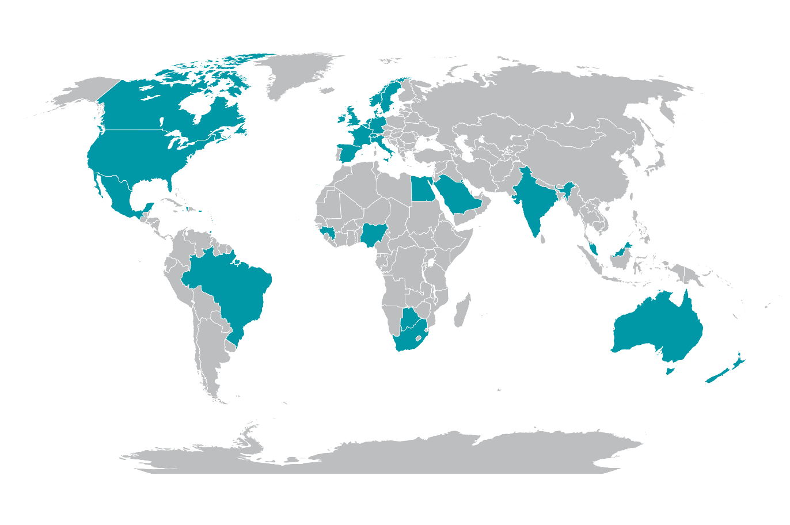  Malaysia | Saudi Arabia | Zimbabwe
Estonia | Mexico | Scotland
Ethiopia | Netherlands | Singapore

#WMTY22 Figures between 1 – 17 June 2022
- 5,867 tweets
- 1,911 participants
- 19.722 million impressions

4.2 Facebook
Between 1 March 2022 and 31 October 2022 the Facebook page (www.facebook.com/whatmatters2you) attracted an additional 218 followers bringing the total number to 1,014. Due to changes to Facebook algorithms it has not been possible to extract other comparative figures.
4.3 Website
The website (www.whatmatterstoyou.scot) was refreshed as part of the preparations for the WMTY 22 campaign and draws interest throughout the year with peaks both before and after June, this is illustrated in the graph below. Sessions are defined as the period of time a user is active on the website.

5 Case Study
This section presents a case study from NHS Tayside, highlighting the importance of staff being asked ‘What matters to you?’
More case studies can be found on our website at: www.whatmatterstoyou.scot

Surgical Acute Frailty Team
Ninewells Hospital, NHS Tayside

‘Good leadership within healthcare is ensuring that your team’s wellbeing is protected as well as to improve their experiences of the health and care system' (NMC, 2018). As part of NHS Tayside’s values, our priority is to put the patients’ first. The What Matters To You (WMTY) approach is a fantastic platform to ensure that our patients’ needs and wishes are discussed, acted upon and at the centre of what we do. We are all aware of the hardships put upon our healthcare professionals, especially after the difficulties experienced by all during the covid pandemic. To ensure that we can help our staff continue to provide the best possible care to our patients, we felt that this year’s WMTY22 day should focus upon our staff – after all, we cannot expect our staff to ask patients ‘what matters to you?’ if we do not ask what matters to our staff first.
Initially, there was some hesitation about how this would be received across the surgical floor – would it produce negative comments and open ‘a can of worms’. With the support of the lead surgical nurse and senior nurse, we felt this would inspire and display the genuine regard we hold for all our hard working healthcare professionals involved in caring for patients. By asking staff this simple yet effective question, our aim was that this would then enable and empower them to go and ask patients the same question in many different ways.
On the 9th of June, a brief presentation on WMTY was given to ward based staff across the unscheduled care surgical floor and included all members from the various disciplines. The presentation was a brief talk on the importance of WMTY as a person centred care approach, and how this can be embedded in daily patient care. After the presentation, a blank space questionnaire with the WMTY logo was given out to staff. Once staff had time to think and respond to the WMTY questionnaire, they were asked to place it anonymously into a sealed

box. It was a particularly busy day across the wards; however, despite the challenges of a busy clinical environment, forty-nine responses were received.
These responses were then broken down into six key themes – communication, teamwork, staffing, patient centred care, leadership and family/personal. Interestingly, 25% of comments highlighted positive team work, emphasising that our clinical teams work well together and value a supportive environment. Teamwork and the importance of a supportive team was highlighted throughout, with comments often referring to the ‘work family’. When mentioning patient centred care, staff clearly wanted to ensure their patients received the best possible care and that their individual needs were met, reinforcing their continued passion for the profession despite difficult capacity challenges currently. The importance of being heard in the workplace was also evident, and it was clear that staff felt genuinely supported in their day-to-day job by the leadership team.
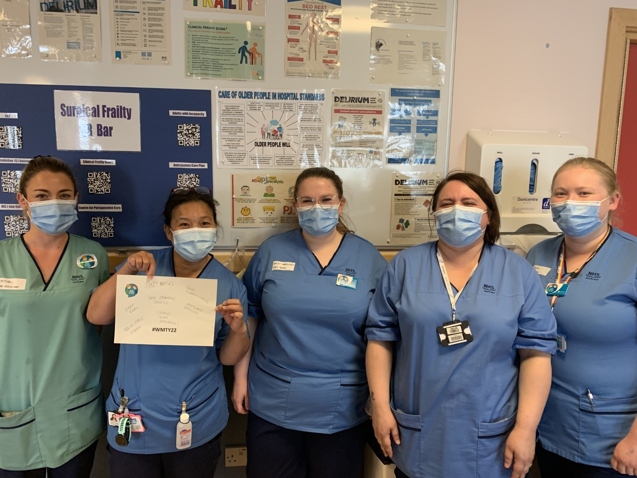
The Ward 12 team at Ninewells Hospital, NHS Tayside, taking part in WMTY day 2022.

Despite some negative comments in relation to staffing and capacity, these were written in a constructive and respectful manner. Nonetheless, staff were motivated by the engagement and genuinely felt that they had been listened to, highlighting the importance of how a patient may feel when they are asked the same question. As a result, this has empowered staff to have similar conversations with their patients. By raising awareness of the importance of having person centred conversations, we hope we can continue to build on the success of this approach. Our take home message to others who may be a little apprehensive about asking their teams ‘what matters to you?’ is to please go ahead and do so. Engage with your teams so that they, in turn, can engage with their patients. You may be very pleasantly surprised with the outcome! We shall continue to build upon the success of this staff engagement and ensure that we ask our staff regularly ‘What matters to you?’, as we expect our staff to be asking this very important question in many different ways to our patients, on a daily basis.

6 Key learning and next steps
6.1 After each WMTY day, time is taken to reflect on how to maximise the impact the following year so that more people can benefit from thinking about and acting on this important question and engagement methodology. In 2022 this has been more important than ever, largely due to the covid pandemic. We have identified the following as key learning and development issues from WMTY day 2022.
6.2 Participation in WMTY day 2022 increased in all of the different areas we are currently able to measure and in some areas it increased considerably, specifically around registration numbers, and in relation to social media and website activity. The international appeal of WMTY day continued, with seven new countries registering to participate in 2022. Various other countries also coordinated the day within their own nations and continued to link in with the Scottish team, although only registrations directly made via the website are included in this report. For WMTY 2023 we will continue to build engagement and involvement across all sectors.
6.3 Further changes to the www.whatmatterstoyou.scot website took place in 2022 leading up to WMTY day and we will continue to review and improve the website, ensuring that it is more interactive and also updated regularly with new case studies from a range of different settings and sectors.
6.4 We plan to host two WMTY Networking events in different regions of Scotland in early 2023. The programme for these will be agreed towards the end of 2022 and will be subsequently shared. It is anticipated that these will centre on education and capacity building, sharing of good practice and showcasing case studies shared with us and also provide an opportunity for individuals and organisations to share with us their needs and aspirations when it comes to WMTY.
6.5 One challenge continues to be how to turn all of the anecdotal evidence on the embedding of the WMTY principle, into hard evidence on the difference it is making in the daily lives of patients, carers and staff. The setting up of the Healthcare Improvement Scotland Community Engagement Directorate Internal WMTY Working Group will help support this. Using engagement office staff, data measurement and research analyst representation, work will commence to determine how impact can be comprehensively measured, along with the associated outcomes and outputs.
6.6 As the WMTY movement goes forward into its eighth year, it is vital that momentum is maintained and links with other national priorities are strengthened. Embedding the ‘What matters to you?’ approach into everything we do is at the very heart of the Scottish Government’s person-centred care ambition. The foundation principle of high quality care and support is that it always begins with asking about what matters, listening to what matters, and perhaps most importantly, doing what matters.

7 Appendix 1 – Working Group 2022
Shaun Maher WMTY Chair, Strategic Advisor for Person-Centred Care
and Improvement - Scottish Government
Kevin Ward WMTY Co-ordinator, Area Manager Healthcare Improvement
Scotland - Community Engagement
Sarah Cox WMTY Administrator, Healthcare Improvement Scotland - Community
Engagement
Diane Graham Senior Improvement Advisor, Healthcare Improvement Scotland
Jennifer Rodgers Deputy Nurse Director, NHS Greater Glasgow & Clyde
Farah Farzana Race Equality Mainstreaming Officer, CEMVO
Susan Siegel Public Partner, Healthcare Improvement Scotland
Dave Bertin Public Partner, Healthcare Improvement Scotland
Tommy Whitelaw National Lead for Carers and Outreach, Health and Social Care
Alliance Scotland
Tony McGowan Head of Engagement & Equalities Policy, Healthcare Improvement Scotland - Community Engagement
Victoria Edmond Senior Communications Officer, Healthcare Improvement Scotland
Kayleigh Keenan Communications Officer, Healthcare Improvement Scotland
Wendy McDougall Community Champion, SeeMe Scotland
Jean McQueen Principal Educator, NHS Education for Scotland

