

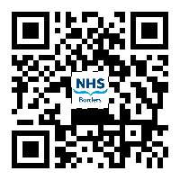
Name: Known As:
Ward: CHI:
Date of admission:
Scan the QR code to find out more about the What Matters To You program, or visit www.whatmatterstoyou.scot

